Multinational Company Manages information of Employees. Each Employee has unique ID. Each Employee works on project in some department.

1. ER Diagram:

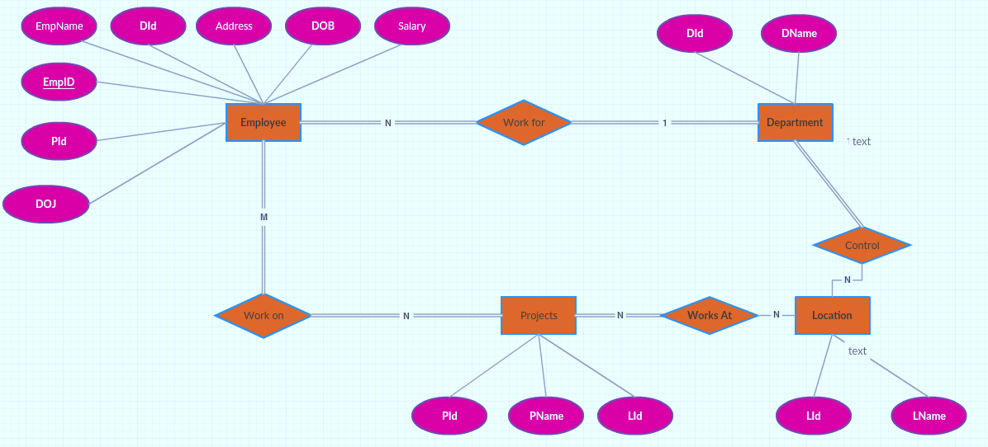

1. DDL and DCL:

# DCL -

create database **mydb**; use **mydb**;

create user **ashish@localhost** identified by ‘test’123; grant all on **mydb** to **ashish@localhost**;

revoke all on **mydb** from **ashish@localhost**;

# DDL

CREATE TABLE Employee

(EmpId INT AUTO_INCREMENT PRIMARY KEY, EmpName VARCHAR(20), Address VARCHAR(30), DOJ DATE, DOB DATE, Salary INT NOT NULL, DId INT, Pid INT, FOREIGN KEY (DId) REFERENCES DEPARTMENT(DId));

CREATE VIEW salary_high AS SELECT EmpId,EmpName FROM Employee WHERE (Salary>50000);

ALTER TABLE Employee ADD Designation VARCHAR(30); ALTER TABLE Employee MODIFY EName VARCHAR(40);

ALTER TABLE Employee DROP DOB;

CREATE INDEX EIndex ON Employee(EmpName); DROP INDEX EIndex;

DROP TABLE Employee;